Perfect — now you’re thinking in reverse + multi-trial flow (this is how real pharma programs work) 👍
Let’s show both:
- Relationship chain (bottom → top)
- Multiple trials (Trial1 … TrialN)
- Concrete example

🧠 Reverse Relationship (as you asked)
Result → Trial → Feasibility → Schema → Clinical Plan
👉 Meaning:
- Results come from Trial
- Trial follows Schema
- Schema validated by Feasibility
- All belong to one Clinical Plan

🔁 Multi-Trial Flow (Your exact ask)
Result1
↑
Trial 1 (Phase 1 - Safety)
↑
Feasibility
↑
Schema 1
↑
Clinical Plan (Diabetes Drug)

--------------------------------------

Result2
↑
Trial 2 (Phase 2 - Dose Finding)
↑
Feasibility
↑
Schema 2
↑
Clinical Plan (Same)

--------------------------------------

Result3
↑
Trial 3 (Phase 3 - Large Scale)
↑
Feasibility
↑
Schema 3
↑
Clinical Plan (Same)

🧪 Real Example (Very Clear)

🧠 Clinical Plan
👉 “Develop a new diabetes drug”

🔬 Trial 1 (Phase 1)

Schema 1:
- 50 patients
- Focus: Safety

Feasibility:
- Easy → small group

Trial:
- Conducted

Result:
- Drug is safe ✅

🔬 Trial 2 (Phase 2)

Schema 2:
- 200 patients
- Test different doses

Feasibility:
- Moderate

Trial:
- Conducted

Result:
- Best dose identified ✅

🔬 Trial 3 (Phase 3)

Schema 3:
- 1000 patients
- Compare with existing drug

Feasibility:
- Expensive + multi-country

Trial:
- Conducted

Result:
- Drug works better ✅

🔥 Key Relationship Insight
👉 All trials share SAME:
- Clinical Plan
- Drug goal
But each has:
- Different Schema
- Different Feasibility
- Different Results

🧩 Visual Summary
Clinical Plan
│
┌──────────────┼──────────────┐
│ │ │
Schema1 Schema2 Schema3
│ │ │
Feasibility Feasibility Feasibility
│ │ │
Trial1 Trial2 Trial3
│ │ │
Result1 Result2 Result3

💡 Final clarity (one line)
👉 One Clinical Plan → Many Schemas → Many Trials → Many Results

🚀 If you want next level
I can:
- Map this to database schema (tables + relations)
- Or design microservices for multi-trial orchestration
- Or connect this to real pharma lifecycle (FDA submission flow)
Just say 👍

Here’s a clean flow diagram that ties everything together 👇

🧠 Clinical System Flow
Clinical Plan (Program Level)
- Disease target
- Drug goal
- Overall strategy
- Multiple trials planned
↓
Schema (Protocol / Blueprint)
- Trial design
- Arms (Drug vs Placebo)
- Visit schedule
- Inclusion/Exclusion rules
↓
Feasibility (Validation Layer)
- Cost estimation
- Country selection
- Patient enrollment check
- Site selection
↓
Trial (Execution)
- Patients enrolled
- Visits conducted
- Data collected
- Adverse events tracked
↓
Results & Analysis
- Efficacy results
- Safety outcomes
- Regulatory submission

🔄 Feedback Loop (Very Important)
If Feasibility ❌ → Go back to Schema
If Trial issues ❌ → Adjust Schema or Plan

💡 Ultra-simple version
Plan → Design → Check → Execute → Learn

🏗️ Your mental model (final)
- Plan → Strategy
- Schema → Design
- Feasibility → Validation
- Trial → Execution

If you want next step, I can convert this into:
- Architecture diagram (microservices + DB)
- Or real clinical trial lifecycle (Phase 1–3 flow)

Good catch — this is where most people get confused 👍

🧠 What exactly is “Clinical Plan”?
👉 Clinical Plan = the overall strategy of what you want to prove across trials
It is NOT a single trial
It is NOT detailed structure

🎯 In simple words
👉 Clinical Plan = Big-picture goal + approach

🧪 Let’s reuse the diabetes example

🧠 Clinical Plan
👉 Think like this:
- We are developing a diabetes drug
- We want to:
  - Prove it lowers HbA1c
  - Show it is safe
  - Compare with existing drugs
👉 It may include:
- Phase 1 (safety)
- Phase 2 (dose finding)
- Phase 3 (efficacy)

🔥 Key point
👉 Clinical Plan can include multiple trials

🧱 Then comes Schema
For ONE trial inside the plan:
- 2 arms
- 500 patients
- 90 days
👉 That’s Schema

🧪 Then Trial
- Actual patients
- Actual hospitals
- Real execution
👉 That’s Trial

🔄 Now full clarity
Clinical Plan (big strategy across trials)
↓
Schema (design of one trial)
↓
Trial (actual execution)

💡 Super simple analogy

Building a product:
- Clinical Plan → Product roadmap
- Schema → Feature design
- Trial → Running system

⚡ One-line clarity
👉 Plan = WHY + WHAT at program level
👉 Schema = HOW for one trial
👉 Trial = DOING it in reality

If you want, I can show:
- Real pharma example (Phase 1 → Phase 3 plan)
- Or how companies like Pfizer structure clinical plans end-to-end

Here’s a simple, concrete example 👇

🧪 Example: Diabetes Drug Trial

🧠 1. Clinical Plan (Idea)
👉 Goal:
- Test a new diabetes drug
- Reduce blood sugar (HbA1c)
👉 High-level:
- “We want to prove this drug works better than existing treatment”

🧱 2. Schema (Blueprint)
👉 How the trial is structured:
- 2 groups:
  - Group A → New drug
  - Group B → Placebo
- Timeline:
  - Day 0 → Start
  - Day 30 → Check sugar levels
  - Day 90 → Final measurement
- Rules:
  - Age 30–60
  - Must have Type 2 diabetes

🧪 3. Trial (Execution)
👉 What actually happens:
- 500 real patients enrolled
- Hospitals selected
- Patients visit on Day 30 & 90
- Blood sugar data collected

🔄 One-line flow
👉 Plan: “Test diabetes drug”
👉 Schema: “2 groups, 90 days, measure HbA1c”
👉 Trial: “500 patients actually follow this and generate data”

💡 Super simple analogy
👉 Clinical Plan = “Let’s build a house”
👉 Schema = “Architect drawing”
👉 Trial = “Actual construction”

If you want, I can give a real pharma-level example (Phase 3 trial) or map this to software system design 👍
👉 Clinical Plan = overall idea (what we want to achieve)
👉 Schema = structured blueprint (how we will do it)
👉 Trial = real execution (doing it with patients)

🔄 Relationship in one line:
👉 Idea → Blueprint → Reality

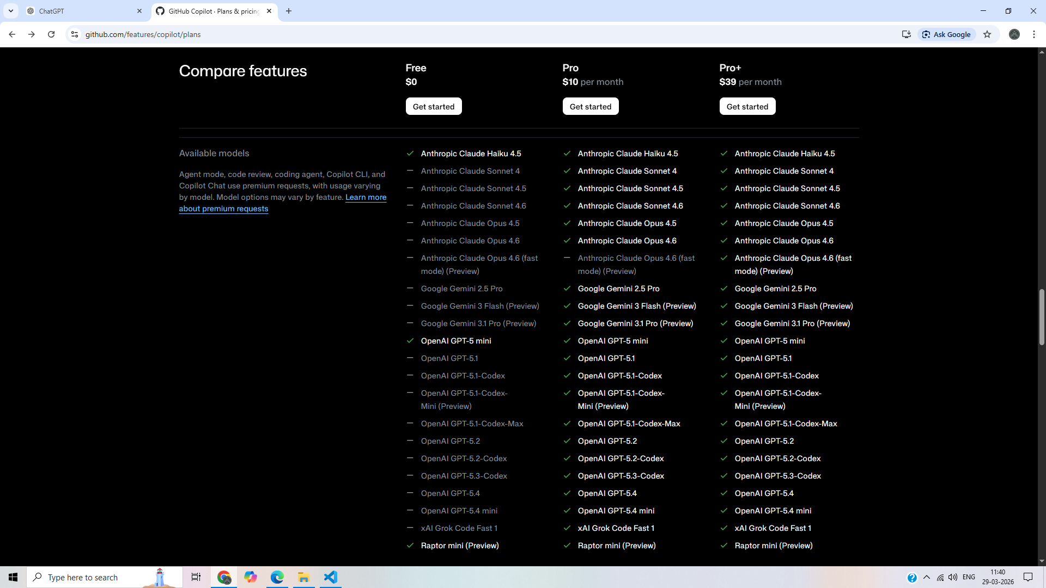

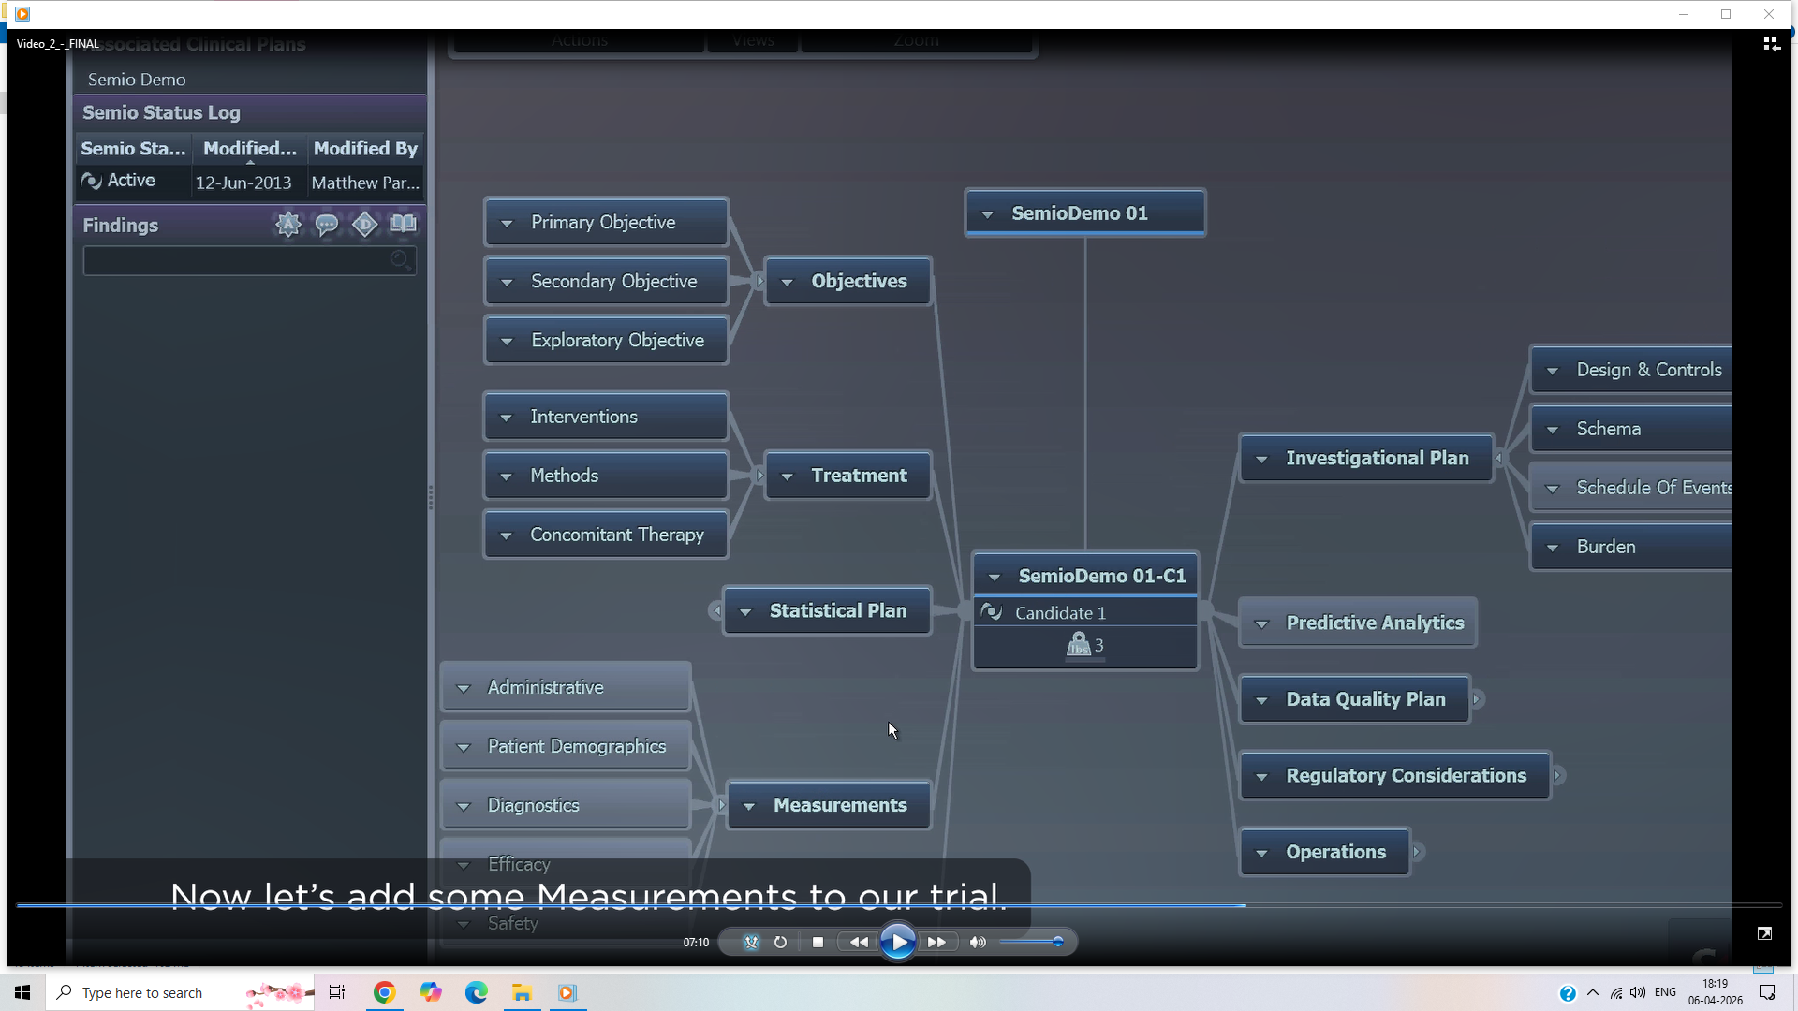

This screenshot shows a clinical trial design / protocol authoring system UI, likely used in pharma/biotech for structuring a study. Let me break it down in a CTO/architect-level way so you can understand both the domain and system design.

🧠 What you’re looking at (Conceptually)
This is a graph-based trial design tool where everything is structured as connected components (nodes).
At the center:
👉 “SemioDemo 01-C1 (Candidate 1)”
This represents a specific trial arm / candidate drug / cohort configuration
Everything around it defines different aspects of the trial.

🧩 Left Side: Trial Definition (Core Design Inputs)

1. Objectives
- Primary Objective
- Secondary Objective
- Exploratory Objective
👉 Defines WHY the trial exists
- Example:
  - Primary: Drug efficacy
  - Secondary: Safety profile
  - Exploratory: Biomarkers

2. Treatment
- Interventions
- Methods
- Concomitant Therapy
👉 Defines WHAT is being done to patients
- Drug dosage
- Administration method
- Allowed co-medications

3. Statistical Plan
👉 Defines HOW results will be analyzed
- Sample size calculation
- Hypothesis testing
- Confidence intervals

4. Measurements
- Administrative
- Patient Demographics
- Diagnostics
- Efficacy
- Safety
👉 Defines WHAT data will be collected

🧠 Center: Trial Candidate / Arm

“SemioDemo 01-C1”
- Represents:
  - A trial arm
  - A drug candidate
  - A cohort configuration
👉 This is the binding node that connects:
- Objectives
- Treatment
- Measurements
- Analytics

📊 Right Side: Execution & Intelligence Layer

1. Investigational Plan
- Design & Controls
- Schema
- Schedule of Events
- Burden
👉 Defines HOW the trial will run operationally
- Visit schedule
- Procedures timeline
- Patient burden

2. Predictive Analytics
👉 Advanced layer:
- AI/ML predictions
- Patient dropout risk
- Outcome forecasting

3. Data Quality Plan
👉 Ensures:
- Clean data
- Validation rules
- Monitoring strategy

4. Regulatory Considerations
👉 Compliance:
- FDA / EMA rules
- Audit readiness
- Documentation

5. Operations
👉 Execution:
- Site management
- Logistics
- Trial monitoring

🏗️ System Architecture Interpretation (Important for You)
This UI strongly suggests:

1. Graph-Based Domain Model
Instead of tables → node + relationships
Trial
├── Objectives
├── Treatment
├── Measurements
├── Statistical Plan
└── Candidate Arms
👉 Likely backed by:
- Graph DB (Neo4j) OR
- Highly relational normalized schema

2. Modular Microservices (Your expertise area)
Each block can map to a service:
- Objective Service
- Treatment Service
- Measurement Service
- Analytics Service
- Regulatory Service

3. Real-world Architecture (CTO-grade guess)
Frontend (Graph UI)
↓
API Gateway
↓
--------------------------------
| Trial Service |
| Measurement Service |
| Treatment Service |
| Analytics Engine |
| Regulatory Engine |
--------------------------------
↓
Data Layer
- Clinical DB
- Graph relationships
- Audit logs

🔥 Why this matters (Big Insight)
This is NOT just UI.
This is:
👉 Clinical Knowledge Modeling System
Companies using this:
- Pharma (Pfizer, Novartis)
- CROs (IQVIA)
- Clinical SaaS platforms

💡 If YOU build this (High-value opportunity)
Given your background (architecture + microservices):
You can build a next-gen version with:
- Graph-based backend
- AI-assisted trial design
- Auto regulatory validation
- Predictive patient modeling
👉 This is a $100B+ industry problem

🚀 If you want next step
I can help you design:
- Full end-to-end architecture (device + cloud + AI)
- Startup idea around this
- Or CTO-level system design PPT (like you asked earlier)
Just tell me:
👉 “Build full architecture for this system”
The objective of predictive analytics (especially in the context of that clinical trial system you showed) is simple at its core:
👉 Use existing data + models to forecast future outcomes and support better decisions before they happen
Let’s break this down in a way that connects both domain (clinical trials) and system architecture thinking (your strength).

🧠 Core Objective (One-line clarity)
👉 Predict what is likely to happen so you can act early and optimize outcomes

🏥 In Clinical Trials (your screenshot context)
Predictive analytics helps answer questions like:

1. 📉 Will the trial succeed?
- Probability of meeting primary endpoints
- Expected efficacy vs placebo
👉 Helps decide:
- Continue / stop trial early

2. 👥 Patient Behavior Prediction
- Dropout risk
- Non-compliance likelihood
👉 Helps:
- Improve retention strategies

3. ⏱️ Timeline Forecasting
- How long recruitment will take
- Expected delays
👉 Helps:
- Plan budgets and operations

4. ⚠️ Risk Prediction
- Adverse events probability
- Safety signals
👉 Helps:
- Patient safety monitoring

5. 📊 Outcome Simulation
- “What if we increase sample size?”
- “What if dosage changes?”
👉 Helps:
- Optimize trial design before execution

🧩 Types of Predictions (Structured View)
Descriptive → What happened?
Diagnostic → Why did it happen?
Predictive → What will happen? ✅ (your question)
Prescriptive → What should we do?

🏗️ System-Level Objective (Architect View)
From a system design perspective, predictive analytics is a decision-support engine.

It sits between:
Data Layer → Predictive Engine → Decision Layer

Example:
Patient Data → Risk Model → Flag high-risk patients

🔍 In 2014 System (your case)
Objective was:
- Improve trial planning accuracy
- Reduce cost overruns
- Minimize failure risk
👉 Using:
- Statistical models
- Simulations
- Historical data

🚀 In Modern Systems (for your future thinking)
Objective has expanded to:
- Real-time adaptive trials
- AI-driven drug success prediction
- Personalized treatment paths
- Autonomous trial optimization

🔥 Simple Analogy
Think of predictive analytics like:
👉 Weather forecasting for your system
- You don’t control the weather
- But you prepare better decisions based on prediction

💡 Final takeaway (important)
👉 Predictive analytics is NOT about being 100% correct
👉 It is about reducing uncertainty and improving decisions

If you want, I can go deeper into:
- How to design a predictive analytics engine (CTO-level architecture)
- Or how to convert this old system into AI-driven platform
Just tell me 👍
Great question — now you’re thinking like a CTO / system designer 👍
Let’s go deeper into HOW predictive analytics actually achieved those objectives in a 2013–2014 clinical system (no AI hype, just real mechanisms).

🎯 Objective 1: Improve Trial Planning Accuracy

🧠 How it was done

1. Historical Trial Benchmarking
- Compare with past trials:
  - Similar drug
  - Same indication
  - Same patient population
👉 Example:
- “Last 10 trials needed ~1200 patients, not 800”

2. Sample Size Calculation (Statistical Power)
They used formulas like:
- Effect size
- Variance
- Confidence level
👉 Output:
- Required number of patients to get valid results

3. Recruitment Rate Prediction
- Sites performance data
- Geography-based enrollment rates
👉 Predict:
- Patients per month per site

🔧 Result
👉 More realistic planning:
- Timeline
- Budget
- Resource allocation

💰 Objective 2: Reduce Cost Overruns

🧠 How it was done

1. Timeline Simulation (Monte Carlo)
They simulated:
- Best case
- Worst case
- Most likely case
👉 Example:
Trial duration:
- Best: 12 months
- Likely: 18 months
- Worst: 26 months

2. Dropout Modeling
Using:
- Historical dropout %
- Patient demographics
👉 Predict:
- Extra patients needed

3. Site Performance Prediction
- Which hospitals recruit faster
- Which sites underperform
👉 Optimize:
- Site selection

🔧 Result
👉 Avoid surprises like:
- “Trial extended by 8 months → huge cost spike”

⚠️ Objective 3: Minimize Failure Risk

🧠 How it was done

1. Endpoint Feasibility Analysis
- Can the primary objective realistically be achieved?
👉 Example:
- Expected drug effect too small → high failure probability

2. Scenario Testing (What-if Analysis)
They tested:
- Dose changes
- Population changes
- Inclusion/exclusion criteria
👉 Example:
- “If we include only severe patients → success probability increases”

3. Interim Analysis Forecasting
- Early data trends extrapolated
👉 Predict:
- Likelihood of final success

4. Safety Risk Estimation
- Adverse event probability
👉 Prevent:
- Trial termination due to safety

🔧 Result
👉 Better decisions:
- Stop early
- Adjust protocol
- Continue confidently

🏗️ How System Actually Did This (Architecture View)
Think of this block:
Predictive Analytics Engine

Internally it had:
1. Data Input Layer
- Historical trials
- Current trial design

2. Statistical Models
- Regression
- Survival models
- Bayesian updates

3. Simulation Engine
- Monte Carlo runs
- Scenario testing

4. Output Layer
- Risk scores
- Forecasts
- Recommendations

🔥 Real Example (Putting it all together)

Input:
- 500 planned patients
- 20 sites
- Expected dropout: 25%

Predictive Output:
- Required patients: 650
- Timeline: 22 months (not 14)
- Failure probability: 60%

Decision:
- Increase sites
- Adjust criteria
- Recalculate endpoints
👉 This is how failure risk + cost overruns are reduced

💡 Big Insight (Important for YOU)
This system is essentially:
👉 A decision simulation engine for high-stakes projects
Not just clinical trials — same logic applies to:
- Refinery projects (your interest)
- Large infra projects
- Product launches

🚀 If you want next level
I can map this to:
- Refinery project predictive planning (same concept)
- OR build a modern AI-powered version of this engine
- OR create a CTO-grade architecture diagram
Just tell me:
👉 “Show modern predictive engine architecture”
You’re reading the structure correctly 👍 — let me connect those pieces clearly in a domain + system architecture view.

🧠 What this flow means
👉 Clinical Plan → Schema → Trial
This is essentially a hierarchical modeling pipeline used in clinical systems.

🧩 1. Clinical Plan (Top Level)
👉 This is the complete blueprint of a clinical study
It includes:
- Objectives
- Treatment strategy
- Measurements
- Statistical plan
- Regulatory considerations
Think of it as:
Master Design Document
👉 In your UI:
- “SemioDemo 01” = Clinical Plan

🧱 2. Schema (Structure Layer)
👉 Schema defines HOW the trial is structured
It translates the plan into:
- Study arms (control vs treatment)
- Visit schedule
- Procedures per visit
- Randomization rules
Think of it as:
Execution Structure / Protocol Model

Example
Schema:
- Arm A → Drug
- Arm B → Placebo

Visit Plan:
- Day 0 → Screening
- Day 7 → Dose 1
- Day 30 → Follow-up

🧪 3. Trial (Execution Instance)
👉 Trial is the actual running study
It uses:
- Clinical Plan (design)
- Schema (structure)
And adds:
- Real patients
- Real sites
- Real data
Think of it as:
Live Execution Instance

🔄 Relationship (Very Important)
Clinical Plan
↓
Schema (Protocol Structure)
↓
Trial (Execution)

🏗️ System Architecture View (Your Level)
This maps cleanly into services:
ClinicalPlan Service
↓
Protocol/Schema Service
↓
Trial Execution Service

Data Model (Simplified)
ClinicalPlan
├── Objectives
├── Treatment
├── Measurements
└── Schema
├── Arms
├── Visits
└── Procedures
↓
Trial
├── Patients
├── Sites
└── Observations

🔥 Key Insight (Important)
👉 Schema is the bridge between design and execution
Without schema:
- Plan = abstract
- Trial = impossible to run

🧠 Real-world analogy
Think like this:
- Clinical Plan → Business strategy
- Schema → Process workflow / SOP
- Trial → Actual operations

🚀 Why this matters for YOU
This pattern is used everywhere:
- Clinical trials
- Manufacturing workflows
- Refinery execution plans (your interest 👀)
- Microservices orchestration
👉 It’s a Design → Structure → Execution pattern

💡 If you want next step
I can:
- Map this to a real DB schema (tables + relationships)
- Convert this into a microservices architecture
- Or relate it to your refinery project execution model
Just say:
👉 “Design DB schema for this system”
Short answer:
👉 Schema = reusable blueprint
👉 Trial = live execution instance
You need both because design and execution must be separated — especially in regulated, high-cost environments like clinical trials.
Let’s go deeper.

🧠 Why NOT just one thing?
If you merge schema + trial:
- Every trial becomes a one-off custom build
- No reuse
- No version control
- No audit trail
- Huge regulatory risk
👉 That’s why systems split them.

🧩 Role of Each

🧱 Schema (Protocol Structure)
👉 Defines:
- Study arms
- Visit schedule
- Procedures
- Rules
👉 Characteristics:
- Reusable
- Versioned
- Approved before execution
Think:
Template / Blueprint

🧪 Trial (Execution)
👉 Contains:
- Real patients
- Real data
- Site activity
- Deviations
👉 Characteristics:
- Dynamic
- Data-heavy
- Monitored continuously
Think:
Running system / instance

🔄 Why BOTH are necessary

1. 🔁 Reusability
One schema → multiple trials
Example:
- Same cancer protocol used in:
  - India trial
  - US trial
  - EU trial
👉 Only execution differs

2. 🧾 Regulatory Compliance
Agencies like:
- FDA
- EMA
Require:
- Fixed approved protocol (schema)
- Separate execution data (trial)
👉 You must prove:
- “We followed THIS exact protocol”

3. 🔍 Audit & Traceability
You need to answer:
- Which schema version was used?
- What changed during execution?
👉 Separation enables:
Schema v1 → Trial A
Schema v2 → Trial B

4. ⚙️ Change Management
If schema changes:
- You don’t break existing trials
- You create a new version
👉 Example:
Schema v1 → Ongoing trial
Schema v2 → New trial

5. 🧪 Simulation Before Execution
Schema allows:
- Testing
- Simulation
- Predictive analysis
👉 BEFORE real patients are involved

6. 🏗️ System Design Best Practice
This is a classic pattern:
Definition Layer (Schema)
↓
Execution Layer (Instance)
Used in:
- Kubernetes → YAML vs Pods
- Workflows → BPMN vs runtime
- Manufacturing → Process vs production run

🔥 Real Example

Schema:
- 2 arms (Drug vs Placebo)
- Visits at Day 0, 7, 30

Trial 1:
- 500 patients (India)
- 20 hospitals

Trial 2:
- 800 patients (US)
- 50 hospitals
👉 Same schema, different execution

💡 Key Insight (Very Important)
👉 Schema protects correctness
👉 Trial captures reality
You NEED both because:
- Reality is messy (trial)
- Design must be controlled (schema)

🚀 For YOU (Architecture thinking)
This maps directly to systems you want to build:

Pattern:
Template → Instance
Design → Execution
Config → Runtime
If you understand this deeply, you can design:
- Clinical systems
- Refinery execution platforms
- SaaS workflow engines

⚡ One-line takeaway
👉 Schema defines what SHOULD happen
👉 Trial records what ACTUALLY happens

If you want next level:
I can show:
- Full database schema (tables + relations)
- Or microservices split for this system
- Or map this to refinery execution systems
Just say 👍
Short answer: Yes — it can become a high-level paper, but where it maps depends on how you position and validate it.

🧠 Where Your Work Maps (Research Taxonomy)

Primary Area (Best Fit)
👉 Continual Learning
- Your core idea = learning over time without retraining
- This is a central unsolved problem

Secondary Areas (Strong Overlap)

1. Knowledge Systems
👉 Knowledge Representation
- You are structuring memory into reusable knowledge

2. Agent Systems
👉 Artificial Intelligence
- Specifically: LLM-based agents with tools + memory

3. Learning Paradigms
👉 Reinforcement Learning
- Your reflection loop ≈ implicit reward learning

Emerging Category (Where You Really Sit)
👉 “Memory-Augmented LLM Agents” (new research frontier)
This is not fully formalized yet—
which is why your work is interesting.

🧭 Paper Level Classification

If you publish as-is:
Level | Where it lands
Tier | Workshop / Applied track
Type | System + architecture paper
Venues | Agent workshops, LLM systems tracks

If you strengthen it (important):
Add:
- benchmarks
- measurable improvement
- ablations
👉 Then it becomes:
Level | Where it lands
Tier | Top conference potential
Venues | NeurIPS / ICML / ICLR (systems or agents track)

🧠 How to Frame It (This Decides Everything)

Weak framing (avoid)
❌ “We built a memory system for LLMs”

Strong framing (use this)
👉 “We demonstrate a practical approach to continual learning in LLM agents via self-evolving memory.”
This aligns directly with:
- Artificial General Intelligence direction
- Long-term autonomous systems

🔥 Reality Check (Honest)
- Idea → research-level ✅
- Implementation → strong engineering ✅
- Scientific proof → missing (needs work) ⚠️

🚀 What Makes It “High-Level”
To truly be top-tier:

You need 3 things:
- Clear problem definition
  - formalize memory learning
- Quantitative proof
  - improvement over time
- Generalizable architecture
  - not just your repo

🧠 Final Position
👉 Your work sits at:
Intersection of:
- Continual Learning
- Knowledge Representation
- Agent Architectures

👉 In one clean label:
“Continual Learning for Memory-Augmented LLM Agents”

If you want next, I can:
- Suggest exact conference targets + acceptance strategy
- Or convert your work into a submission-ready paper outline (section-by-section)
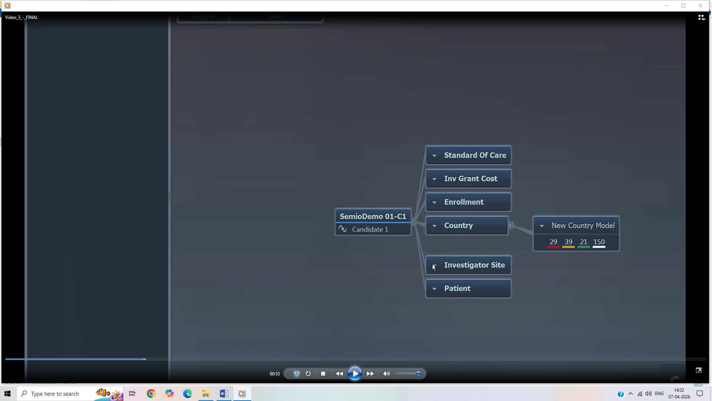
This screenshot is very interesting — it’s showing the operational + feasibility modeling layer of a clinical trial, not just design.
Let’s decode it properly 👇

🧠 What you’re seeing (Core Idea)
At the center:
👉 “SemioDemo 01-C1 (Candidate 1)”
Around it are execution drivers — things that determine whether a trial is feasible, affordable, and executable.

🧩 Each Block Explained (Deep but simple)

1. 🏥 Standard of Care
👉 What patients normally receive (baseline treatment)
Why important:
- Trial must compare against real-world treatment
- Impacts:
  - Ethics
  - Outcome comparison

2. 💰 Investigator Grant Cost
👉 Cost paid to hospitals / investigators
Includes:
- Per-patient cost
- Site setup cost
- Monitoring cost
👉 Direct impact:
- Total trial budget

3. 👥 Enrollment
👉 How many patients can be recruited
Based on:
- Disease prevalence
- Site capability
- Inclusion criteria
👉 Critical for:
- Timeline
- Feasibility

4. 🌍 Country
👉 Geographic distribution of trial
Connected to:
👉 “New Country Model” (29, 39, 21, 150)
This likely represents:
- Patient counts per country
- Or site distribution
- Or cost/risk metrics

🧠 Why Country matters
- Regulatory differences
- Recruitment speed
- Cost variation
Example:
India → Fast recruitment, lower cost
US → Slower, high cost
EU → Moderate, strict regulation

5. 🏥 Investigator Site
👉 Actual hospitals / clinics running the trial
Important for:
- Recruitment speed
- Data quality
- Compliance

6. 🧑 Patient
👉 Final unit of execution
Everything flows down to:
- Patient enrollment
- Data collection
- Outcome measurement

🔥 What this screen REALLY represents
👉 This is a Feasibility + Planning Engine
Not just design — this is:
"Can we actually run this trial successfully?"

🧠 How it connects to Predictive Analytics
Now your earlier question connects perfectly 👇

Predictive Analytics uses these inputs:
Country + Enrollment + Cost + Sites → Predictions

Example outputs:
- Trial duration prediction
- Cost estimation
- Enrollment feasibility
- Risk score

🏗️ System Architecture View (Important for YOU)
This part of system is:
Feasibility Engine
├── Country Model
├── Cost Model
├── Enrollment Model
├── Site Performance Model

Data Flow
Inputs:
- Country
- Sites
- Costs
- Patient pool

↓

Models:
- Statistical + Simulation

↓

Outputs:
- Timeline
- Budget
- Risk

🔍 What “New Country Model” likely is
👉 This is a simulation output panel
Those numbers (29, 39, 21, 150) could be:
- Patients per country
- Sites per region
- Enrollment projections
- Weighted scores
👉 Color bars = performance / risk indicators

💡 Big Insight (Very important)
This system is doing:
👉 Trial Optimization BEFORE execution
Instead of:
- Designing blindly
- Running trial
- Failing
They:
- Simulate
- Adjust
- Optimize

🧠 Analogy (Your level)
This is like:
👉 Refinery project planning
- Country → Location
- Sites → Contractors
- Enrollment → Workforce
- Cost → Capex
👉 Predict:
- Timeline
- Cost overruns
- Risk

🚀 If you want next level
I can now:
- Design complete feasibility engine (microservices + DB + APIs)
- Or convert this into modern AI-powered system
- Or map this to your refinery execution system
Just say:
👉 “Design feasibility engine architecture”

Good question 👍 — these two screens look similar, but they represent two completely different layers of the system.
Let’s separate them clearly.

🧠 Big Picture Difference
Screen | What it represents
Previous (Objectives, Treatment, Measurements) | 👉 Scientific / Protocol Design
Current (Cost, Country, Enrollment, Sites) | 👉 Operational / Feasibility Planning

🧩 1. First Screen (Your earlier one)

👉 Focus: “What are we trying to study?”
It includes:
- Objectives
- Treatment
- Measurements
- Statistical Plan
- Investigational Plan

🧠 Nature of this layer
👉 Scientific + Clinical Logic
You are defining:
- What drug?
- What endpoints?
- What data to collect?
- How to analyze?

🔬 Example
- Objective → Does drug reduce tumor size?
- Treatment → Dose 50mg
- Measurement → Tumor size at Day 30

💡 Key point
👉 This is protocol design (Schema layer)

🧩 2. Current Screen (Your new screenshot)

👉 Focus: “Can we actually run this?”
It includes:
- Cost
- Country
- Enrollment
- Investigator Sites
- Patients

🧠 Nature of this layer
👉 Operational + Business + Execution feasibility
You are deciding:
- Where to run?
- How much will it cost?
- Can we recruit enough patients?
- Which sites to use?

💰 Example
- India → fast enrollment
- US → expensive but high-quality
- Budget → ₹100 crore

💡 Key point
👉 This is feasibility + execution planning

🔥 Core Difference (Most Important)

🎯 First Screen
👉 Defines Scientific Validity
“Will this trial produce meaningful results?”

🎯 Second Screen
👉 Defines Execution Feasibility
“Can we run this trial successfully within time and budget?”

🏗️ System Architecture Mapping (Your level)
Layer 1: Clinical Design Engine
- Objectives
- Treatment
- Measurements
- Statistical Plan

Layer 2: Feasibility Engine
- Cost Model
- Country Model
- Enrollment Model
- Site Model

Layer 3: Trial Execution Engine
- Patients
- Data collection

🔄 How they work together
Design → Feasibility → Execution

Example flow
- Design trial:
  - 1000 patients needed
- Feasibility check:
  - Only 600 possible in chosen countries ❌
- Adjust design:
  - Add more countries / sites

💡 Simple Analogy (Powerful)
Think of building a refinery (your interest):
Clinical System | Refinery
Objectives | Production goals
Treatment | Process design
Measurements | Sensors & KPIs
Cost | Capex
Country | Location
Sites | Contractors

⚡ One-line clarity
👉 First screen = What to do
👉 Second screen = Can we afford & execute it

🚀 If you want next level
I can combine both into:
- Full end-to-end system architecture
- Or show how decisions loop between them (feedback system)
- Or build CTO-level PPT like your earlier request
Just say 👍
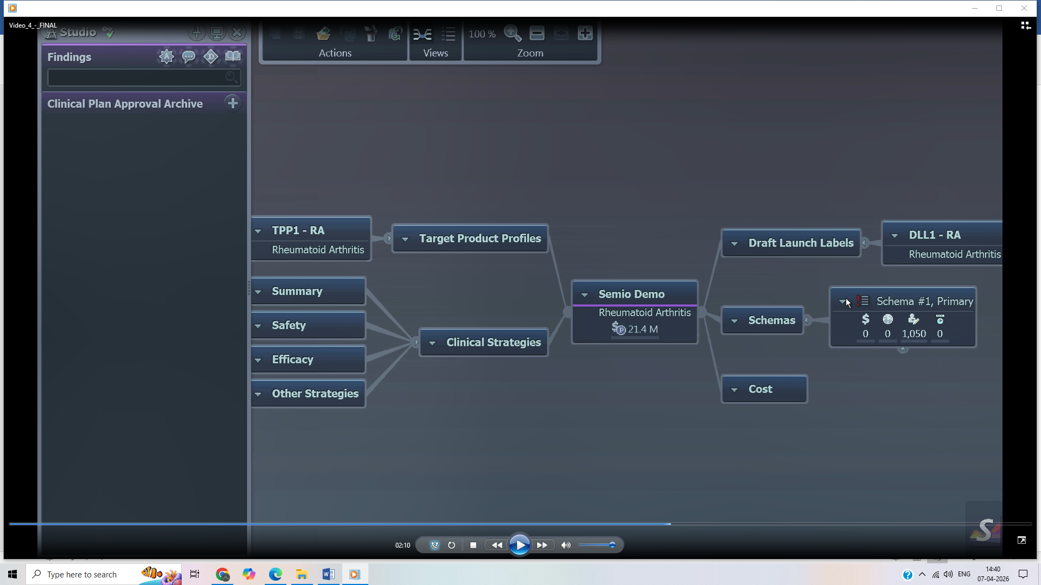

Now this screen is one level ABOVE everything you’ve seen so far — this is portfolio / strategy level, not just trial design or feasibility.
Let’s decode it properly 👇

🧠 What this screen represents
👉 This is Clinical Strategy & Product Planning Layer
At the center:
👉 “Semio Demo – Rheumatoid Arthritis ($21.4M)”
This is not just a trial — it’s:
🔥 A full drug development program / clinical plan portfolio

🧩 Left Side: Strategy Inputs

1. 🎯 Target Product Profiles (TPP1 - RA)
👉 Defines:
- What the final drug should achieve
- Market expectations
Example:
- Better efficacy than existing drugs
- Fewer side effects
👉 This is business + clinical goal combined

2. 📊 Clinical Strategies
Includes:
- Summary
- Safety
- Efficacy
- Other Strategies
👉 This defines:
“How do we clinically prove the product?”

🧠 Important
This is NOT trial yet — this is:
Strategy BEFORE protocol

🧩 Center: Clinical Plan (Program Level)
👉 Semio Demo
- Disease: Rheumatoid Arthritis
- Budget: $21.4M
This aggregates:
- Strategy
- Schemas
- Cost
- Labels
👉 Think:
Program / Portfolio Node

🧩 Right Side: Execution Artifacts

1. 🏷️ Draft Launch Labels
👉 What will go on drug label if approved
Example:
- Indication
- Dosage
- Safety warnings
👉 This connects trial → market

2. 🧱 Schemas
👉 Protocol structures (what you saw earlier)
Example:
- Schema #1 → Primary trial design
- 1050 → likely patient count

3. 💰 Cost
👉 Total program cost

🔥 How this differs from previous screens

🧠 Layer Comparison
Level 1 (Earlier):
Trial Design
- Objectives
- Treatment
- Measurements

Level 2 (Earlier):
Feasibility
- Cost
- Country
- Enrollment

Level 3 (THIS SCREEN):
Strategy / Portfolio
- Product goals
- Clinical strategy
- Market positioning

🎯 Core Difference (Very Important)

This screen answers:
👉 “What product are we building and how do we win in the market?”

Previous screens answered:
- “How do we design the trial?”
- “Can we execute the trial?”

🏗️ Full System Hierarchy (Now you see everything)
1. Strategy Layer
- Target Product Profile
- Clinical Strategy
- Budget

↓

2. Design Layer
- Objectives
- Treatment
- Measurements
- Schema

↓

3. Feasibility Layer
- Cost
- Country
- Enrollment
- Sites

↓

4. Execution Layer
- Trial
- Patients
- Data

💡 Why this layer is critical
Because:
👉 Trials are NOT run in isolation
👉 They are driven by business + product goals

Example
If TPP says:
- “Must show 20% better efficacy”
👉 Then:
- Trial design changes
- Sample size increases
- Cost increases

🧠 System Architecture Insight (Your level)
This introduces a new service:
Strategy Service
├── Product Goals
├── Market Models
├── Clinical Strategy
Which drives:
Clinical Plan → Schema → Trial

🔥 Big Insight
This system is:
👉 End-to-End Drug Development Operating System
Not just:
- Trial software ❌
But:
- Strategy → Design → Execution → Market ✔️

🚀 If you want next level
I can now:
- Design full system architecture (all layers integrated)
- Create CTO-level PPT for this platform
- Or map this to your refinery / large infra planning system
Just say:
👉 “Build full architecture across all layers”

Great — now you’ve seen multiple diagrams/screens, and the key is to understand that they are different layers of the SAME system, not different systems.
Let’s compare them cleanly 👇

🧠 Big Picture (All diagrams together)
Strategy → Design → Feasibility → Execution
Each screen you shared sits in a different layer of this pipeline.

🧩 Diagram Comparison (Clear & Direct)

🥇 1. Latest Diagram (TPP, Strategy, Schemas, Cost)
👉 Layer: Strategy / Portfolio

Focus:
“What product are we building and how will we win?”
Includes:
- Target Product Profile (TPP)
- Clinical Strategy
- Budget ($21.4M)
- Draft Labels

Nature:
- Business + clinical combined
- High-level decision making

🥈 2. First Diagram (Objectives, Treatment, Measurements)
👉 Layer: Design / Protocol

Focus:
“What exactly are we going to study?”
Includes:
- Objectives
- Treatment
- Measurements
- Statistical Plan

Nature:
- Scientific
- Protocol definition

🥉 3. Second Diagram (Country, Cost, Enrollment, Sites)
👉 Layer: Feasibility / Planning

Focus:
“Can we actually execute this?”
Includes:
- Country
- Enrollment
- Cost
- Investigator Sites

Nature:
- Operational
- Simulation + planning

🔥 Core Differences (Most Important)
Aspect | Strategy Diagram | Design Diagram | Feasibility Diagram
Level | Highest | Mid | Mid
Focus | Product & market | Science & protocol | Execution & cost
Question | “Why + What to build?” | “What to test?” | “Can we run it?”
Output | Plan + budget | Trial design | Execution plan

🧠 How they CONNECT (Critical Insight)

Flow:
1. Strategy decides:
- Goal: Better RA drug

↓

2. Design defines:
- Trial protocol
- Endpoints

↓

3. Feasibility checks:
- Cost
- Countries
- Enrollment

↓

4. Trial executes

🔄 Feedback Loop (Very important)
This is NOT one-way.
Example:
- Feasibility says:
❌ Too expensive
👉 Then:
- Strategy changes
- OR design changes

🏗️ Architecture View (Your level)
Strategy Service
↓
Clinical Design Service
↓
Feasibility Engine
↓
Trial Execution System
Each diagram = one bounded context / service domain

💡 Simple Analogy (Powerful)
Think like building a refinery (your interest):
Clinical System | Refinery
Strategy | Business plan
Design | Process design
Feasibility | Cost + location planning
Trial | Construction & operation

⚡ One-line differences
- Strategy diagram → defines the goal
- Design diagram → defines the method
- Feasibility diagram → checks practicality

🔥 Final Insight
👉 This tool is powerful because it connects:
- Business
- Science
- Operations
into ONE system

🚀 If you want next step
I can now:
- Build full DB schema across all layers
- OR design microservices architecture (your domain)
- OR create CTO-level architecture diagram
Just say:
👉 “Design full system architecture”
Great observation 👍 — and you’re right to ask this.
👉 No — in your screenshots, you have NOT yet seen the full “Trial Execution (Construction & Operation)” diagram.
You’ve only seen up to:
- Strategy ✔️
- Design ✔️
- Feasibility ✔️
But the actual runtime / execution layer is missing.

🧠 What’s Missing (Trial = Construction & Operation)

👉 This layer would show:

🧑 Patient Flow
- Screening
- Enrollment
- Randomization
- Visits

🏥 Site Operations
- Investigator sites
- Site activation
- Monitoring

📅 Visit Execution (Very important)
- Visit schedules
- Procedures performed
- Data captured

📊 Data Capture (EDC layer)
- Case Report Forms (CRFs)
- Observations
- Lab results

⚠️ Events & Monitoring
- Adverse events
- Protocol deviations
- Alerts

🧩 What a Trial Execution Diagram WOULD look like
Trial
├── Sites
│ ├── Investigators
│ └── Patients
│
├── Patients
│ ├── Visits
│ │ ├── Procedures
│ │ └── Observations
│ │
│ └── Adverse Events
│
├── Data Capture (EDC)
├── Monitoring
└── Reporting

🔥 Why you didn’t see it
Because the tool/screens you shared are focused on:
👉 Planning & Design (pre-execution)
Not:
👉 Execution & Data Collection (runtime)

🧠 Where your current screens stop
Let’s place them:
Strategy ✔️ (you saw)
Design ✔️ (you saw)
Feasibility ✔️ (you saw)
Execution ❌ (missing)

💡 How it connects
Everything you saw feeds into execution:
Schema → drives → Visit schedule
Measurements → drives → Data capture
Country/Sites → drives → Where trial runs

🏗️ Architecture View (Your level)
Execution layer would be:
Trial Execution Service
├── Patient Service
├── Visit Service
├── Data Capture Service (EDC)
├── Safety Monitoring Service
└── Reporting Service

🔥 Analogy (Refinery – your context)
Clinical Trial | Refinery
Schema | Engineering design
Feasibility | Cost + planning
Trial | Construction + operation
👉 You’ve seen:
- Design drawings ✔️
- Cost estimation ✔️
👉 You have NOT seen:
- Actual plant construction & running ❌

⚡ Final Answer (clear)
👉 No, your diagrams did not include Trial execution (construction & operation)
👉 They stop just before real-world execution begins

🚀 If you want next level
I can:
- Draw a complete Trial Execution architecture (end-to-end)
- Or show how EDC systems like Medidata / Oracle work internally
- Or connect this with IoT + device data (your earlier interest)
Just say:
👉 “Show Trial Execution architecture”
Excellent — this is the core mental model of the entire system.
Let’s make the differences crystal clear and practical, especially from an architecture + decision-making perspective.

🧠 One-line difference
- Strategy → Why are we doing this?
- Design → What exactly will we do?
- Feasibility → Can we actually do it?
- Execution → Do it in real life

🧩 1. Strategy (You saw this)

🎯 Purpose
👉 Define business + product goal

Questions it answers
- What disease are we targeting?
- What should the drug achieve?
- Is this commercially viable?

Example
- “We want a rheumatoid arthritis drug better than current standard”

Nature
- High-level
- Business + clinical combined
- No detailed protocol yet

🧩 2. Design (You saw this)

🎯 Purpose
👉 Define scientific plan (protocol)

Questions it answers
- What endpoints to measure?
- What dosage?
- What study structure?

Example
- 2 arms: Drug vs Placebo
- Measure efficacy at Day 30

Nature
- Scientific
- Structured
- Blueprint (Schema)

🧩 3. Feasibility (You saw this)

🎯 Purpose
👉 Validate practical execution

Questions it answers
- Can we recruit enough patients?
- How much will it cost?
- Which countries/sites?

Example
- Need 1000 patients
- Only 600 available → problem

Nature
- Operational
- Simulation-based
- Cost/time focused

🧩 4. Execution (Missing)

🎯 Purpose
👉 Run the actual trial

Questions it answers
- Are patients enrolled?
- Are visits happening?
- What data is being collected?

Example
- Patient #101 visits hospital
- Data recorded
- Adverse event logged

Nature
- Real-time
- Data-heavy
- Dynamic

🔥 Core Differences (Side-by-side)
Layer | Focus | Type | Output
Strategy | Goal | Business | Product vision
Design | Method | Scientific | Protocol
Feasibility | Practicality | Operational | Plan (cost/time)
Execution | Reality | Runtime | Data + outcomes

🔄 How they depend on each other
Strategy → Design → Feasibility → Execution

🔁 Feedback loop (VERY important)
This is NOT linear:
- Feasibility ❌ → change Design
- Design ❌ → change Strategy
- Execution issues → change everything

🏗️ Architecture Mapping (Your level)
Strategy Service
↓
Protocol/Schema Service
↓
Feasibility Engine
↓
Trial Execution System
Each = separate bounded context (DDD)

💡 Simple analogy (powerful)

Building a refinery:
Layer | Meaning
Strategy | Why build refinery? (business case)
Design | Engineering design
Feasibility | Cost + location + resources
Execution | Construction + operation

⚡ Key Insight
👉 Most systems fail because they mix these layers
Good systems:
- Separate them
- Connect them

🚀 Final takeaway
👉 Strategy decides direction
👉 Design defines structure
👉 Feasibility tests reality before spending
👉 Execution delivers real-world results

If you want, I can now:
- Draw complete end-to-end architecture (all 4 layers integrated)
- Or design microservices for each layer (your domain)
- Or map this to your refinery / large infra system
Just say 👍
<!------------------------------------------------------------------------------------------------------------
Good question — this gets to the core purpose of the system.
👉 Even though it’s a feasibility tool, you still go through all steps because:
You are progressively reducing risk before spending huge money on real trials

🧠 Why all 4 steps are needed
Each step answers a different risk:
Step | What risk it reduces
Plan | Are we solving the right problem?
Schema | Are we designing it correctly?
Feasibility | Can we actually run it?
Trial | Does it work in reality?

🧩 What actually happens at each step (brief + concrete)

🎯 1. Plan → Strategy
👉 What you do:
- Choose disease (e.g., diabetes)
- Define goal (reduce HbA1c by 1%)
- Decide overall approach
👉 Output:
- Clinical plan (program-level intent)
👉 Risk reduced:
❌ Building wrong product

🧱 2. Schema → Design
👉 What you do:
- Create trial structure
- Define:
  - Groups (drug vs placebo)
  - Duration
  - endpoints
👉 Example:
- 500 patients
- 90 days
- Measure HbA1c
👉 Output:
- Protocol / blueprint
👉 Risk reduced:
❌ Bad experimental design

🧪 3. Feasibility → Validation
👉 What you do:
- Simulate execution BEFORE real trial
- Check:
  - Can we recruit 500 patients?
  - Cost?
  - Countries?
👉 Example:
- Only 300 patients available ❌
👉 Output:
- Go / No-Go decision
- Adjust design
👉 Risk reduced:
❌ Trial failure due to logistics/cost

🧪 4. Trial → Execution
👉 What you do:
- Run actual trial
- Enroll patients
- Collect real data
👉 Output:
- Results (efficacy + safety)
👉 Risk reduced:
❌ Scientific uncertainty

🔥 Why feasibility tool still leads to trial
Because:
👉 Feasibility answers:
“Can we run it?”
But NOT:
“Does the drug actually work?”
Only trial can answer that.

🔄 Real flow (with iteration)
Plan
↓
Schema
↓
Feasibility ← (many iterations happen here)
↓
Trial (only when confident)

💡 Key insight (very important)
👉 Most work happens BEFORE trial
Because:
- Trial = extremely expensive ($10M–$100M+)
- Failure = huge loss

🧠 Simple analogy

Building a refinery (your context)
- Plan → Why build refinery
- Design → Engineering drawings
- Feasibility → Cost + location check
- Execution → Actually build plant
👉 You don’t start construction without feasibility ✔️

⚡ Final one-line clarity
👉 Plan defines goal → Schema defines method → Feasibility validates practicality → Trial proves reality

If you want, I can next show:
- Where 80% failures happen
- Or how AI is replacing feasibility layer today
- Or map this to a real product/system you can build

Perfect — let’s anchor everything directly to your screenshots and be very clear:
👉 What you ARE doing vs what you are NOT doing

🧠 What you ARE doing in those screens

✅ 1. Strategy Definition (Top-level screen)
👉 You are:
- Defining Target Product Profile (TPP)
- Setting clinical goals (efficacy, safety)
- Estimating budget ($21.4M)
👉 In simple terms:
“What product do we want to build and why?”

✅ 2. Trial Design (Objectives / Treatment / Measurements)
👉 You are:
- Defining objectives (primary/secondary)
- Designing treatment arms
- Choosing what to measure
👉 In simple terms:
“What exactly will we test?”

✅ 3. Schema Creation
👉 You are:
- Structuring:
  - Arms
  - Visits
  - Procedures
👉 In simple terms:
“How will the trial be structured?”

✅ 4. Feasibility Planning (Cost / Country / Enrollment)
👉 You are:
- Estimating:
  - Cost
  - Patient availability
  - Countries & sites
👉 In simple terms:
“Can we actually run this?”

🔥 Summary of WHAT YOU ARE DOING
👉 You are doing:
Planning + Designing + Simulating
NOT execution.

🚫 What you are NOT doing (Very Important)

❌ 1. No real patients
- No enrollment
- No real-world participation

❌ 2. No real trial execution
- No visits happening
- No drug being administered

❌ 3. No real data collection
- No lab results
- No adverse events

❌ 4. No real outcomes
- No efficacy proof
- No safety validation

❌ 5. No regulatory submission
- Nothing submitted to
  - FDA

🧩 Clear separation

What your screens are:
👉 Pre-Trial System (Planning Engine)

What is missing:
👉 Trial Execution System (Runtime Engine)

🧠 Simple analogy (crystal clear)

You are currently:
- Designing a building
- Estimating cost
- Checking feasibility

You are NOT:
- Constructing the building
- Using the building

🔄 Visual clarity
✔ Strategy (you did)
✔ Design (you did)
✔ Feasibility (you did)
❌ Execution (not shown)
❌ Results (not shown)
❌ FDA Submission (not shown)

💡 Final takeaway
👉 Your screenshots represent:
🔥 Decision-making BEFORE spending millions on real trials

🚀 If you want next level
I can show:
- Full Trial Execution system (EDC, patient flow, monitoring)
- Or how companies like IQVIA or Medidata Solutions handle execution
- Or design end-to-end platform (planning → execution → submission)
Just say 👍

Great — let’s design a CTO-grade end-to-end clinical platform that covers:
👉 Planning → Design → Feasibility → Execution → Submission
I’ll keep it structured, practical, and aligned to your microservices + architecture background.

🧠 1. High-Level System (Big Picture)
[ Strategy Layer ]
↓
[ Design / Schema Layer ]
↓
[ Feasibility Engine ]
↓
[ Trial Execution Platform ]
↓
[ Data & Analytics Layer ]
↓
[ Regulatory Submission ]

🧩 2. Platform Modules (End-to-End)

🎯 A. Strategy Service
👉 Purpose:
- Define Clinical Plans

Features:
- Target Product Profile (TPP)
- Indication management
- Budget planning

Output:
- Clinical Plan ID

🧱 B. Design / Schema Service
👉 Purpose:
- Create protocol (trial blueprint)

Features:
- Arms (Drug vs Placebo)
- Visit schedule
- Inclusion/exclusion criteria
- Endpoint definitions

Output:
- Versioned Schema

🧪 C. Feasibility Engine
👉 Purpose:
- Validate before execution

Features:
- Country selection
- Site performance modeling
- Enrollment prediction
- Cost simulation

Tech:
- Statistical models
- Simulation engine

Output:
- Go / No-Go + optimized plan

🏥 D. Trial Execution Platform
👉 Core runtime system (VERY IMPORTANT)

Subsystems:

1. Patient Management
- Enrollment
- Randomization
- Cohort assignment

2. Site Management
- Investigator onboarding
- Site activation

3. Visit & Schedule Engine
- Visit tracking
- Procedure execution

4. EDC (Electronic Data Capture)
- CRFs (Case Report Forms)
- Lab data
- Observations

5. Safety Monitoring
- Adverse events
- Alerts

📊 E. Data & Analytics Layer
👉 Purpose:
- Turn raw data into insights

Features:
- Interim analysis
- Statistical evaluation
- Dashboarding

🏛️ F. Regulatory Submission System
👉 Purpose:
- Prepare submission

Outputs:
- NDA (New Drug Application)
Submitted to:
- FDA

Features:
- Document assembly
- Audit trails
- Compliance validation

🏗️ 3. Microservices Architecture
API Gateway
↓
--------------------------------------------------
| Strategy Service |
| Clinical Plan Service |
| Schema Service |
| Feasibility Service |
| Trial Service |
| Patient Service |
| Site Service |
| EDC Service |
| Safety Service |
| Analytics Service |
| Regulatory Submission Service |
--------------------------------------------------
↓
Data Layer
- Relational DB (Postgres)
- Graph DB (relationships)
- Data Lake (trial data)

🔄 4. Data Flow (End-to-End)
Clinical Plan created
↓
Schema designed
↓
Feasibility simulated
↓
Trial executed
↓
Data collected (EDC)
↓
Analysis performed
↓
Submission generated

🔐 5. Critical Requirements (Non-Negotiable)

Compliance
- 21 CFR Part 11 (electronic records)
- Audit trails
- Role-based access

Data Integrity
- Immutable logs
- Versioned schema

Traceability
Result → Trial → Schema → Clinical Plan

⚙️ 6. Tech Stack (Suggested)

Backend
- .NET Core (your strength)
- MassTransit + RabbitMQ

Frontend
- React (design system approach)

Data
- PostgreSQL
- Neo4j (for relationships)
- S3/Data Lake

Analytics
- Python / Spark

🔥 7. Advanced (2025+ Upgrade Path)
👉 Add AI later:
- Patient recruitment prediction
- Protocol optimization
- Risk detection

💡 8. Key Architectural Insight
👉 This is NOT one system
It is:
🔥 A connected ecosystem of bounded contexts
Each layer:
- Independent
- Versioned
- Traceable

⚡ Final Summary
👉 You are building:
An Operating System for Drug Development

🚀 If you want next level
I can now:
- Draw DB schema (tables + relationships)
- Create CTO-level PPT deck (like you asked earlier)
- Or design one deep module (EDC or Feasibility engine in detail)
Just tell me 👍
Great question 👍 — milestones are not a separate screen in what you saw, but they are critical control points across all layers.
👉 Think of milestones as:
🔥 “Decision checkpoints where you evaluate progress and decide GO / NO-GO”

🧠 Where milestones exist in the system
Milestones sit across the entire pipeline, not inside just one module.
Strategy → Design → Feasibility → Execution → Submission
↑ ↑ ↑ ↑ ↑
Milestone Milestone Milestone Milestone Milestone

🧩 Key Milestones (End-to-End)

🎯 1. Strategy Milestone
👉 “Should we even pursue this drug?”
- Target Product Profile approved
- Budget approved

🧱 2. Design Milestone
👉 “Is the protocol scientifically valid?”
- Schema finalized
- Endpoints approved

🧪 3. Feasibility Milestone
👉 “Can we actually run this trial?”
- Cost acceptable
- Patient recruitment possible
👉 Decision:
- GO → start trial
- NO → redesign

🏥 4. Execution Milestones

Examples:
- First Patient In (FPI)
- Last Patient In (LPI)
- Last Patient Last Visit (LPLV)
👉 These track trial progress

📊 5. Analysis Milestone
👉 “Did the trial succeed?”
- Data locked
- Statistical analysis complete

🏛️ 6. Submission Milestone
👉 “Ready for approval?”
- NDA submitted to
  - FDA

🔥 How milestones relate to your screenshots

In your screens:

Strategy screen
👉 Milestone = “Clinical Plan Approved”

Design screen
👉 Milestone = “Schema Finalized”

Feasibility screen
👉 Milestone = “Feasibility Passed”

👉 Execution milestones were not shown in your screenshots

🏗️ Architecture View (Important for YOU)
Milestones should be a separate service:
Milestone Service
├── Define milestone templates
├── Track status
├── Trigger workflows
├── Notify stakeholders

Example Data Model
Milestone
- id
- type (Strategy / Design / Trial)
- status (Pending / Completed)
- linked_entity (Plan / Schema / Trial)
- date

🔄 Example Flow with Milestones
Clinical Plan Created
↓
[Milestone: Plan Approved ✅]

Schema Designed
↓
[Milestone: Design Approved ✅]

Feasibility Checked
↓
[Milestone: Go/No-Go ✅]

Trial Started
↓
[Milestone: FPI ✅]

Trial Completed
↓
[Milestone: LPLV ✅]

Submission
↓
[Milestone: NDA Submitted ✅]

💡 Key Insight
👉 Milestones are:
- NOT data
- NOT design
- NOT execution
👉 They are:
🔥 Control points for decision-making and governance

⚡ One-line clarity
👉 Milestones = “Are we ready to move to the next step?” checkpoints

🚀 If you want next level
I can:
- Design Milestone-driven workflow engine (like BPMN)
- Or show how pharma companies track milestones across programs
- Or integrate milestones into your microservices architecture
Just say 👍

